STREAMLIT INSTALLATION

1 .Must have Anaconda

2.Create new Environment

3.search for Spyder ide and qt console install them both

4 go to streamlit docs online and copy commands

5 in new environment click play button and open terminal

6.paste command pip **install** streamlit

streamlit hello 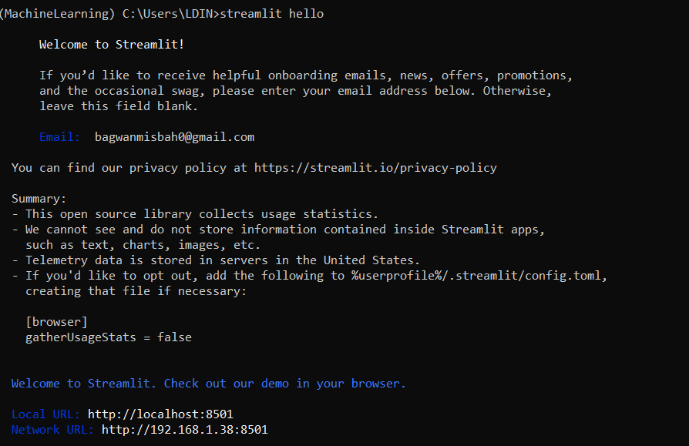

for downloading any package/library

search library name pypi

copy command

click play button on your environment and paste

ex

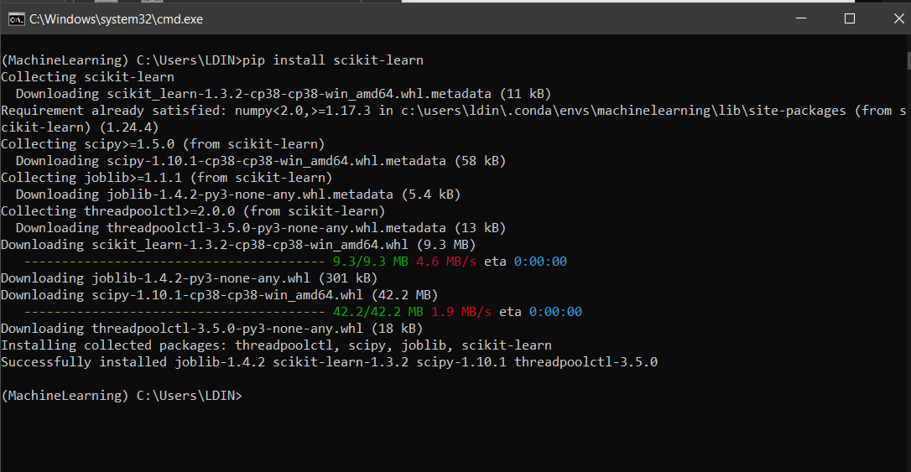

DiabetesPrediction

Save model using pickle in following way

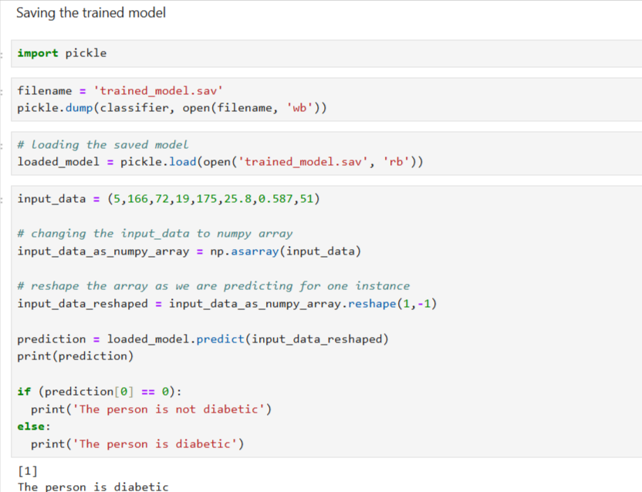

Download sav file

In anaconda navi ,launch SPYDER IDE

Go to env and open terminal w play button again

Write pip install pickle-mixin

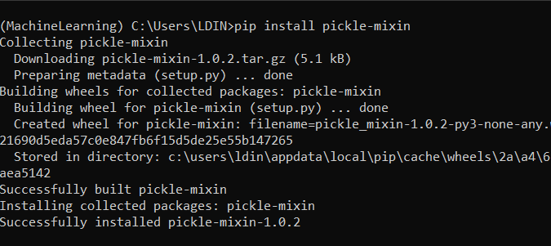

While working in python remember to change backward slashes to forward slashes

Like so

Before: D:\Misbah\PICT STUDY\ML_DP

loadel_model=pickle.load(open('D:/Misbah/PICT STUDY/ML_DP/trained_model.sav','rb'))

IMPORTANT :

Chatgpt:

• You trained your model in **Jupyter Notebook** (which was running in the base environment with **Python 3.12.4**).

• You then tried to run your script in **Spyder** (which was in the MachineLearning environment with **Python 3.10.16**).

• This caused a **version mismatch** when loading the saved .sav model, leading to the InconsistentVersionWarning.

**Why is this a problem?**

* Machine learning models serialized (saved) using pickle are **not always compatible** across different versions of Python and Scikit-learn.
* Since **Jupyter** and **Spyder** were running different Python versions, the model was trained with one version and loaded in another, leading to compatibility issues.

**✅ Lesson for the future:**

* Always **train and deploy** your model in the **same environment**.

**2. Thinking Jupyter Notebook Was Running an Older Python Version**

**What happened?**

* At one point, you thought **Jupyter was running an older Python version** (causing the .sav file to be saved with Scikit-learn 1.4.2).
* But in reality, **Jupyter was actually using the latest Python 3.12.4**.
* The issue wasn’t Python itself—it was that **Jupyter and Spyder were using different environments**.